

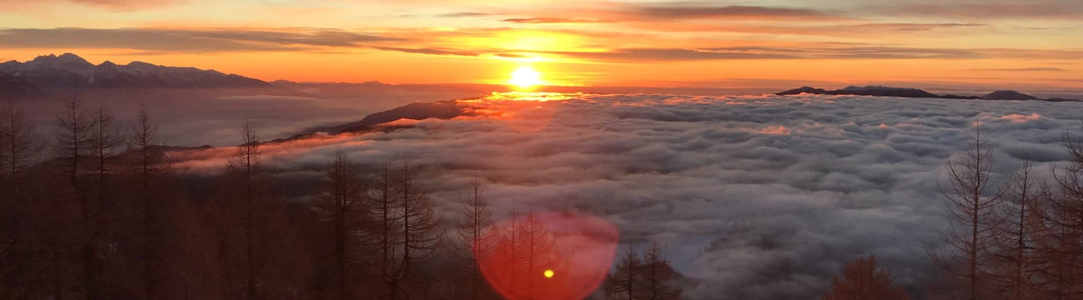

**Focus, Trust, and Deliver**

December 14, 2022

**2022 – A Year in Review**

This is a somewhat unusual end-of-year message. As I want to talk as much about process as achievements for the year. [Nature For Justice](https://www.nature4justice.earth/mission/) (N4J) is a two-year-old organization with big ambitions (i.e., ultimately improving the lives of 100 million people), an expanding set of collaborators (e.g., [Ostrom Climate](https://ostromclimate.com/)), and confidence that our decentralized, partner-centric approach is a strategy worth pursuing.

Bur start-ups are hard. From working with Mohamed Ali Noor in the Somali refugee camps creating a national cookstove program (see [Help People Where They Are](https://www.nature4justice.earth/help-people-where-they-are/)), to scooting around a wetland in Papua New Guinea, pursuing a sustainable timber company in the face of Malaysian opposition, and getting the Forest Stewardship Council back on track in the USA, I know to expect days that leave me questioning myself: “What on earth was I thinking with I committed to this?”

The secret is to **focus, trust,** and **deliver.**

# Focus

During 2022, Nature For Justice’s focus was on getting three very different regional programs off the ground in Africa, Canada, and the USA. Working backward chronologically, in the US [Clarenda Stanley](https://www.linkedin.com/in/clarendastanley/) , N4J’s Managing Director for Farmer Inclusion joined N4J in late September and has created a clear vision and approach for how she wants to take our USA program focused on assisting Black farmers to address the uncertainties of their changing climate. These farmers know what they need, and Farmer Cee (Clarenda) sees our role as one to help them access the resources they have long been withheld.

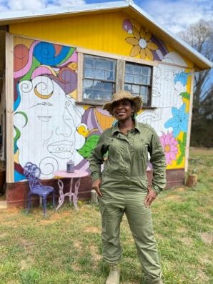In Africa, Michael O’Brien Onyeka (who arguably has the most interesting background and stories of anyone I’ve ever met), has explored and launches programs in Kenya, Zambia, Botswana, Ghana, and South Africa. We recently issued a [Request for Proposals](https://www.nature4justice.earth/nature-based-solutions-projects-in-africa/) to further open the pipeline for Nature-based Solutions programs with the help of [Nicci Mander](https://www.linkedin.com/in/nicola-mander-9b888a22/) at Ecosystemiq. The technical requirements for these potentially 30+ year projects are daunting but Mike, as our EVP for Global Partnerships, is building the foundation for an enduring impact.

Canada is a land of enormous opportunity. We are working with First Nations there to secure and create long-term financing for Indigenous Protected and Conserved Areas (IPCAs). [Steve Nitah](https://www.linkedin.com/in/steven-nitah-14082530/), a former chief of the the ŁuTsël K’e Dene Nation and a leader in creating the Thaidene Nené IPCA, is N4J’s Managing Director for Canada and our global indigenous Peoples’ program lead. He is systematically raising our profile with First Nations on their needs and opportunities (as I write this, Steve is at the UN Biodiversity COP 15 in Montreal speaking on various panels.) A major effort in the new year will be creating a Boreal Avoided Wildfire Emission standard to generate carbon credits across lands controlled by First Nations classified as “[Irrecoverable Carbon](https://www.weforum.org/agenda/2021/11/what-is-irrecoverable-carbon/).”

*Clarenda Stanley, N4J Managing* In addition to these programs that are up and going, in 2022 we started recruiting for regional staff in Latin *Director – Farmer Inclusion* America and South Asia where we have been approached to implement our approach.

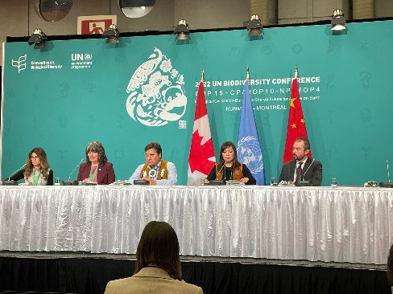Lots of activity but in a start-up, don’t make the mistake of thinking you can go 100% all the time. The work will ebb and flow and, most importantly, be aware of opportunity that require intense effort at specific times.

The best example of this from 2022 is our work with [Gouritz Cluster Biosphere Reserve](https://gouritz.com/) in South Africa. Starting in January, we reviewed seven potential ways to create Nature-based Solutions projects in the 3.2-million-hectare biosphere reserve. Periods of inactivity were punctuated by scrambles to make decision on imperfect but good-enough information. The hustle demonstrated by the [GCBR and N4J teams](https://www.nature4justice.earth/achieving-landscape-scale-ecological-restoration/) has brought us to focus on a potential [Spekboom restoration project](https://www.nature4justice.earth/initiatives/south-africa-gcbr/). No final decision has been made yet but we’re optimistic and, if we do move forward, the hustle demonstrated to date will be needed over the coming months to make it real. *Steven Nitah (center), N4J Managing Director —*

*Canada*

# Trust

There are about 20 people that have N4J email addresses, and few of them are full-time staff or advisors. Technical collaborators number about 10. The number of local, on-the-ground partners for the co-creation of projects is about 15. That is a complex and wonderful mix of personalities, cultures, geographies, and ambitions that I and the senior management team have the pleasure of managing every day.

How to do it? Trust that everyone has agreed to [our mission](https://www.nature4justice.earth/mission/) and is contributing to the best of their abilities:

***We aim for a more just world where people and nature work in tandem   
to confront the impact of the climate crisis.***

# Deliver

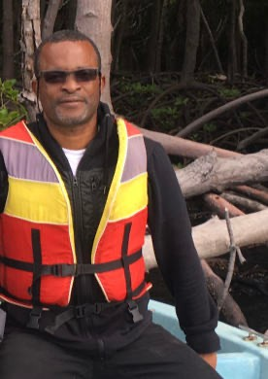Finally, none of it counts if we do not deliver every year on our commitments. At this stage, 2 years in, most of our commitments are interim indicators that demonstrate progress toward our ultimate goals. An example is the many screening notes we developed in Africa led by Mike for new projects that we have identified with partners. Or in Canada, the relationships Steve has built with First Nations through the [Conservation through Reconciliation Partnership](https://www.ilinationhood.ca/) and the [Indigenous Leadership Initiative](https://www.ilinationhood.ca/).

These and many other milestones are important process indicators. By the end of 2023, we plan to report on a cross-section of outcome indicators related to our launches projects’ social, biodiversity, and carbon sequestration results.

So, 2022 has been a whirlwind of a year, and 2023 looks like it will be even more exciting. I am eternally grateful to the many who have contributed to our progress, understand that there will be setbacks, and will rely on our stick-to-it-ness in the face of our changing climate. Our commitment and mission are more important than eve.

*Michael O’Brien-Onyeka, N4J*

*EVP – Global Partnerships*

Please send me your feedback: [hcauly@nature4justice.org](mailto:hcauly@nature4justice.org).

# Author

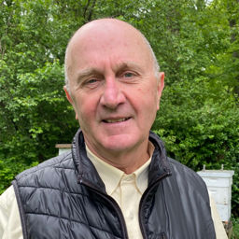

An engineer who later got a business degree to achieve social and environmental justice through existing economic structures. He’s started to build many organizations and projects. Hank lives in Falls Church, VA, with his wife and is an avid bee-keeper.

*Hank Cauley, N4J*

*Co-Founder & CEO*